owner oCCuPied loan CheCklist
- General Information Form (attached or use your own)
- Operating Company Tax Returns for Trailing Three Years
- Current Interim Profit and Loss Statement And Balance Sheet of the Operating Company
(within 60 days)
- Business Debt Schedule (attached or use your own)
- Complete Personal Tax Returns for Trailing Three Years for All Principals
- Personal Financial Statement for All Principals (attached or use your own)
- Resume for Key Principals (attached or use your own)
Investment ProPerty Loan CheCkLIst
- General Information Form (attached or use your own)
- Property Income and Expense Statement for Trailing Three Years
- Current Interim Income and Expense Statement of the Property (Within 60 Days)
- Property Rent Roll (attached or use your own)
- Complete Personal Tax Returns for Trailing Three Years for All Principals
- Personal Financial Statement for All Principals (attached or use your own)
- Resume for Key Principals (attached or use your own)

If you have additional information that you can provide such as a property appraisal, environmental reports, property photos, current credit report(s), etc., please include as this will typically help with the approval process.

General Information Form
Loan Request Information (Please Complete All Information to Avoid Delays in Processing Your Application)
Application For: Purpose of Loan:

Conventional Mortgage SBA Source of Repayment:
Construction loan Church Finance Amount Requested: $
Term Requested:
Amortization Requested:
Collateral Description: 1. | Market Value:  $ | Purchase Price  $ | Date of Purchase
2. | $ | $
3. | $ | $
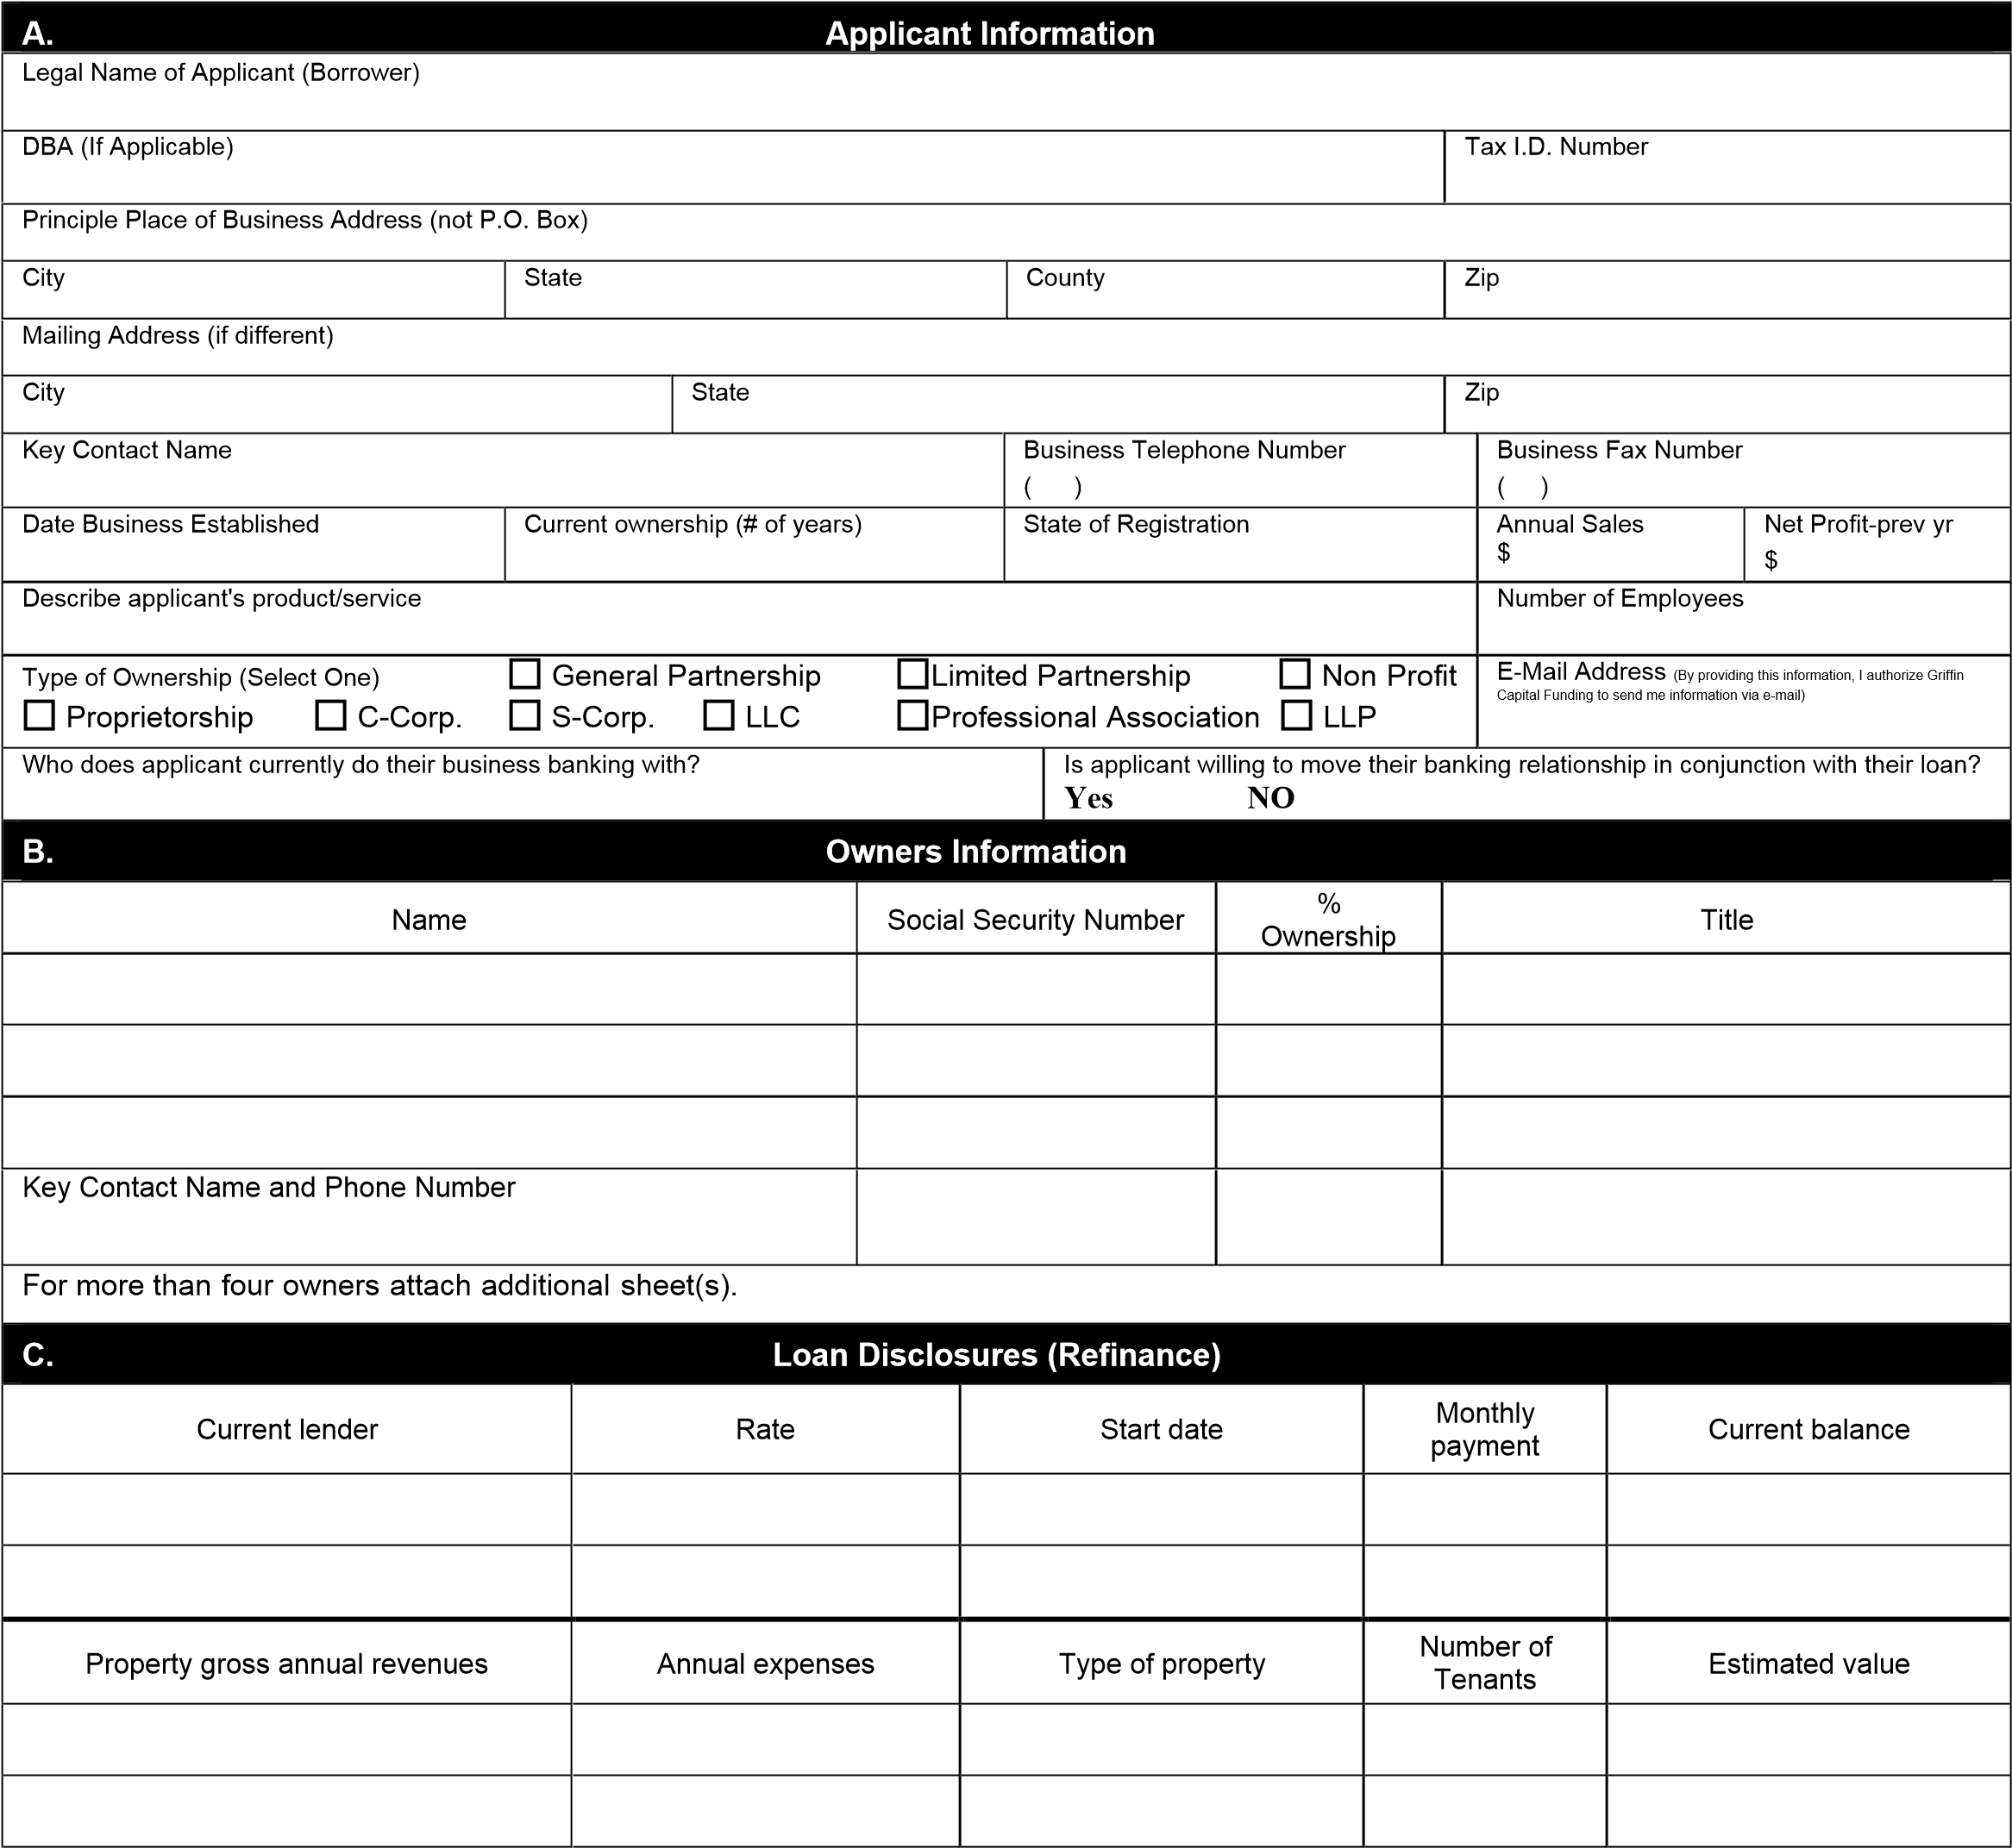

D. Loan Disclosures (Purchase)
Purchase price | Will purchaser occupy 51% or more of the property | Type of property | Down payment | Estimated value
Property gross annual revenues | Annual expenses | Number of tenants | Is the property under contract | Anticipated settlement date
E. Other Information
Settlement agent name Insurance Company Phone Number ( )
Settlement agent phone number Insurance Company Fax Number ( )
Yes* No
Is the seller of the property willing to carry a second trust? (Purchase only)
Has The Applicant Ever Declared Bankruptcy Or Had Any Judgments, Repossessions, Yes* No
Garnishments Or Other Legal Proceeding Filed Against Them?
Is the applicant currently under contract with any other mortgage brokers? Yes* No
Are Any Tax Obligations, Including Payroll or Real Estate Taxes, Past Due? Yes* No
Is The Applicant Liable On Debts Not Shown, Including Any Contingent Liabilities Such As Leases, Yes* No Endorsements, Guarantees, Etc.?
Is The Applicant Currently A Defendant In Any Suit Or Legal Action? Yes* No
*If you answered yes to any of the above questions, please provide an explanation on a separate sheet

F. Certification And Signatures
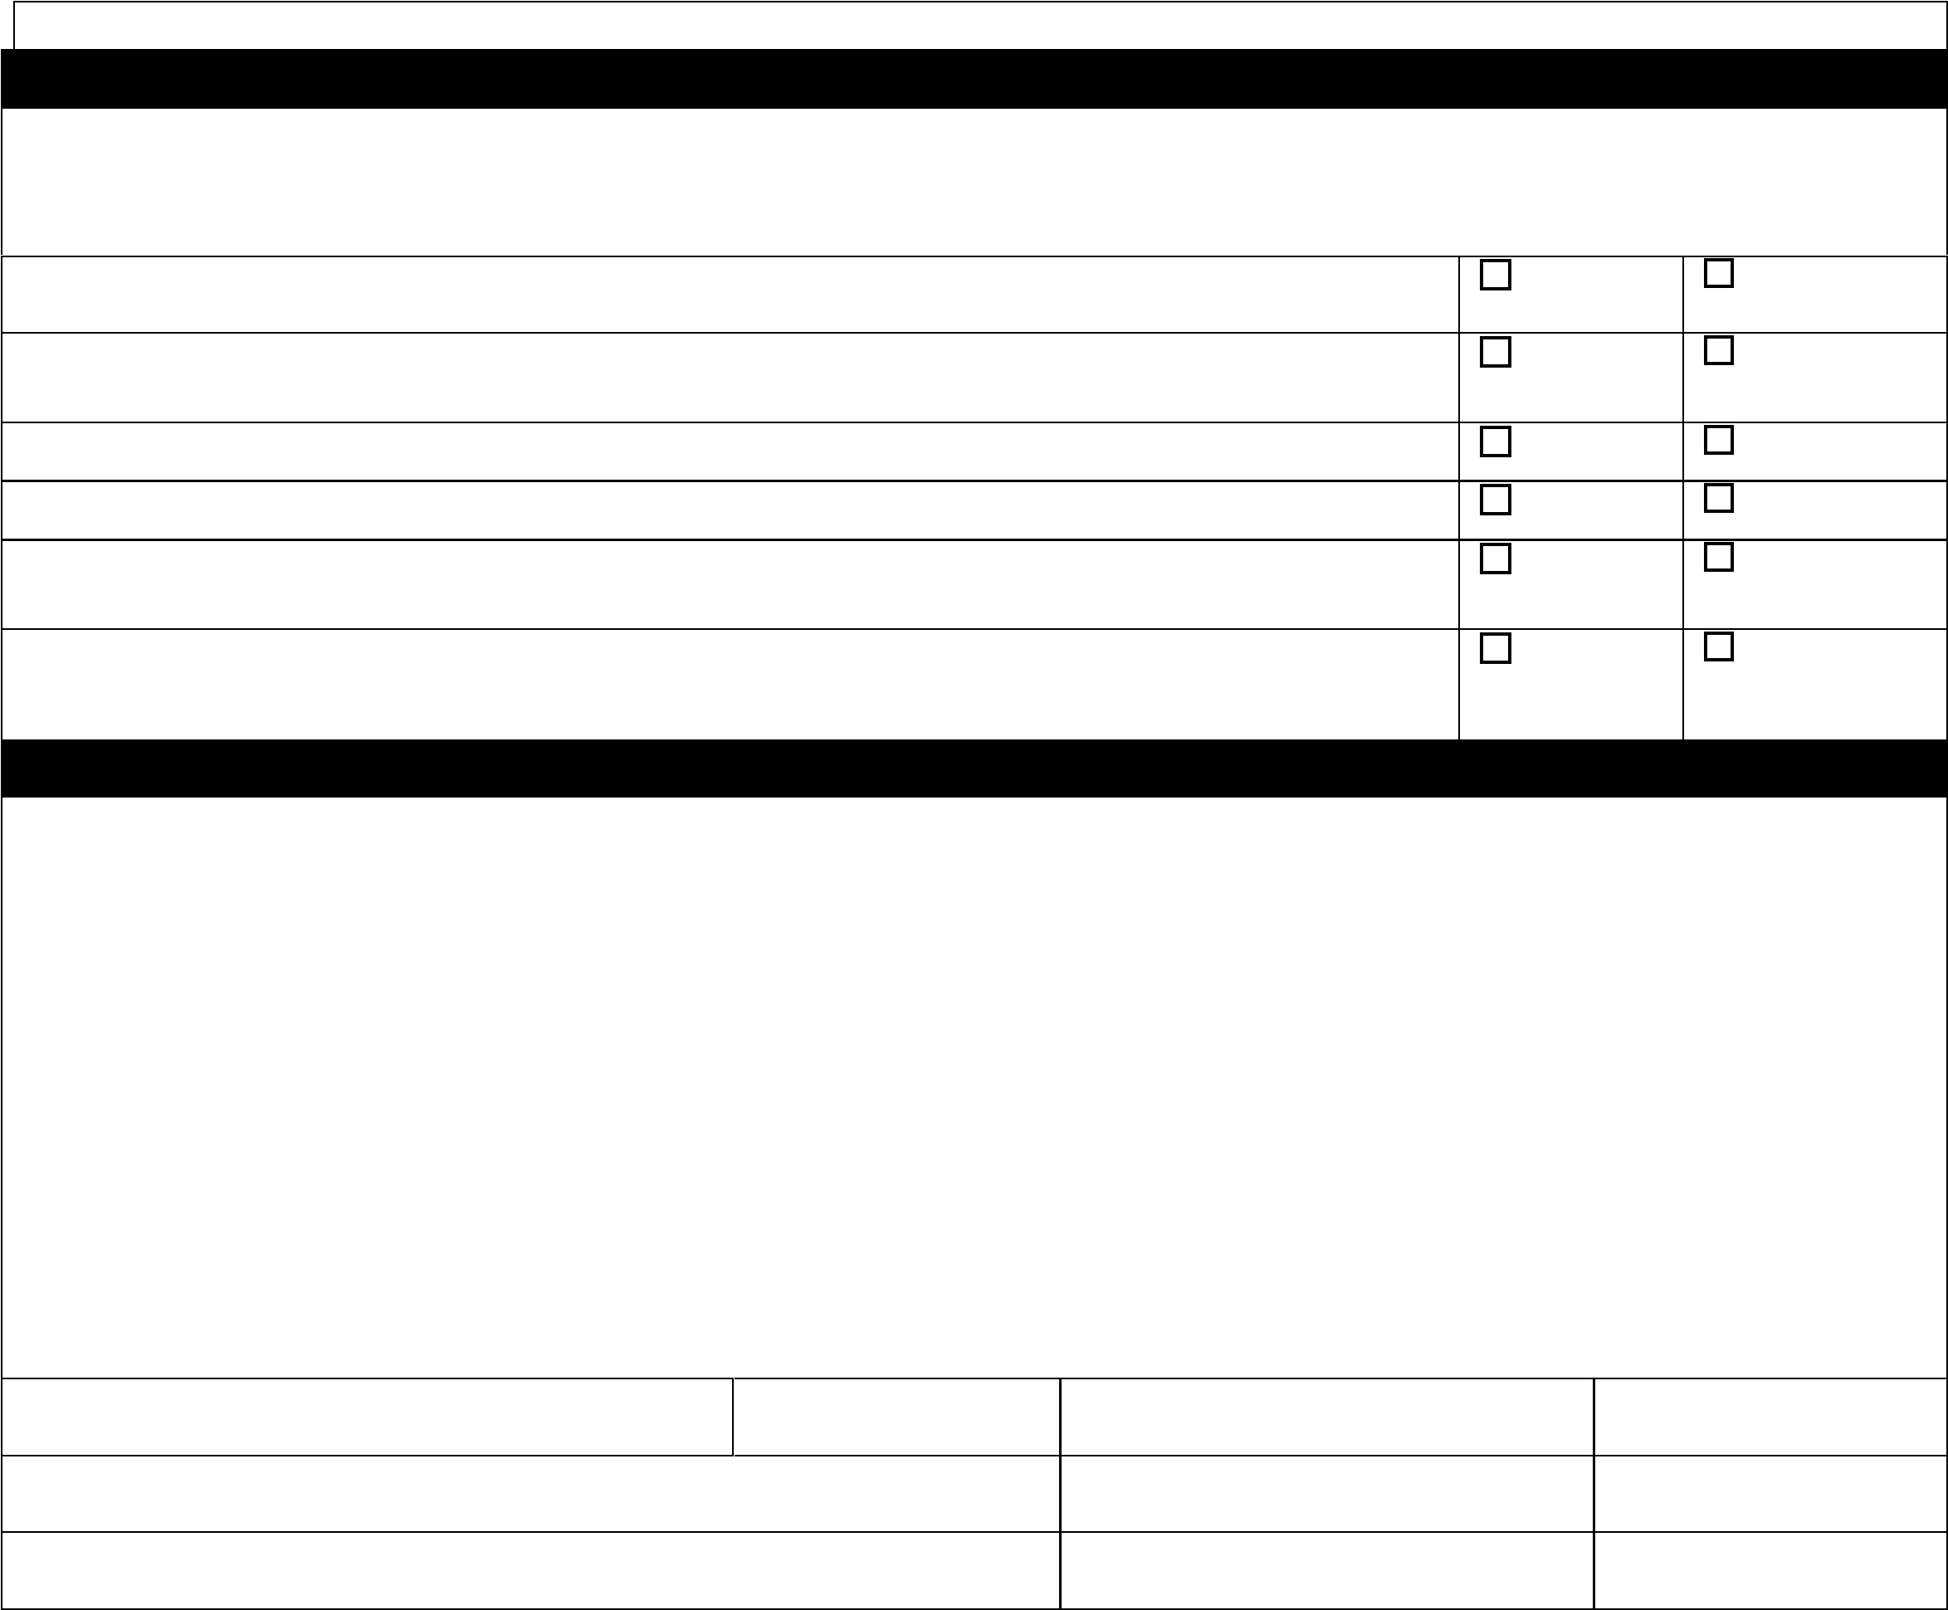
Each of the undersigned hereby instructs, consents and authorizes the Lender/Broker, or any affiliate, subsidiary or assigns to obtain a consumer credit report and any other information relating to their individual credit status in the following circumstances: (a) relating to the opening of an account or upon application for a loan or other product or service offered by Lender by a commercial entity of which the undersigned is a principal, member, guarantor or other party, (b) thereafter, periodically according to the Lender’s credit review and audit procedures, and (c) relating to Lender’s review or collection of a loan, account, or other Lender product or service made or extended to a commercial entity of which the undersigned is a principal, member, guarantor or other party. The Applicant(s), individually and/or by the signature(s) of its authorized representative below, hereby certifies that: the foregoing has been carefully read by the Applicant and is given to the Lender/Broker for the purpose of obtaining the credit described above and other credit from time to time in whatever form; the information in this Application and any other documents or information submitted in connection with this Application or any other credit request are true and correct statements of the Applicant’s financial condition and may be treated by the bank as a continuing statement thereof until replaced by a new Application or until the Applicant specifically notifies Lender/Broker in writing of any change; and the credit requested herein and any other credit obtained from the Lender/Broker by the Applicant on the basis of the information contained in this Application shall be used solely for business and commercial purposes. The Applicant and each Guarantor authorize the Lender/Broker to verify at an time any information submitted to the Lender/Broker by or on behalf of the Applicant and/or any Guarantor; obtain further information concerning the credit standing of the Applicant, its representatives and Guarantors; and exchange such credit information with others. The Applicant agrees to provide additional information, financial or otherwise, upon request and agrees that, unless otherwise directed by the Applicant in writing, all statements and notices regarding any credit granted by the Lender/Broker to the Applicant shall be mailed or faxed to the Applicant at the address or number shown above. Any person(s) signing below is duly authorized and empowered to request credit on behalf of the Applicant.
Unless I/We initial here, the Lender/Broker is hereby authorized to share this application and credit information with its affiliates or other lenders, which may consider my/our application for loan approval/purchase. This statement does not limit the Lender/Broker's rights to sell or assign any loans to a third party. Applicant and each Guarantor initials: _______________
Signature (Applicant) Title Print Name Date
Signature (Guarantor) Print Name Date
Signature (Guarantor) Print Name Date

BUSINESS DEBT SCHEDULE
Furnish the following information on all installment debts, contracts, notes, and mortgages payable. Do not include accounts payable or accrued liabilities.
Business Name:_________________________________________________________________ *As of_____________, 20____ *Should match the financial statement to be submitted.
Creditor  Name/address | Original amount | Original date | Present balance | Interest rate | Maturity date | Monthly payment | Security | Current or delinquent
 |  | Total present balance** |  |  | Total monthly payment
**Total must agree with balance shown on current financial statement
Signature:_________________________________________________________ Title:______________________________________ Date Signed:___________________________

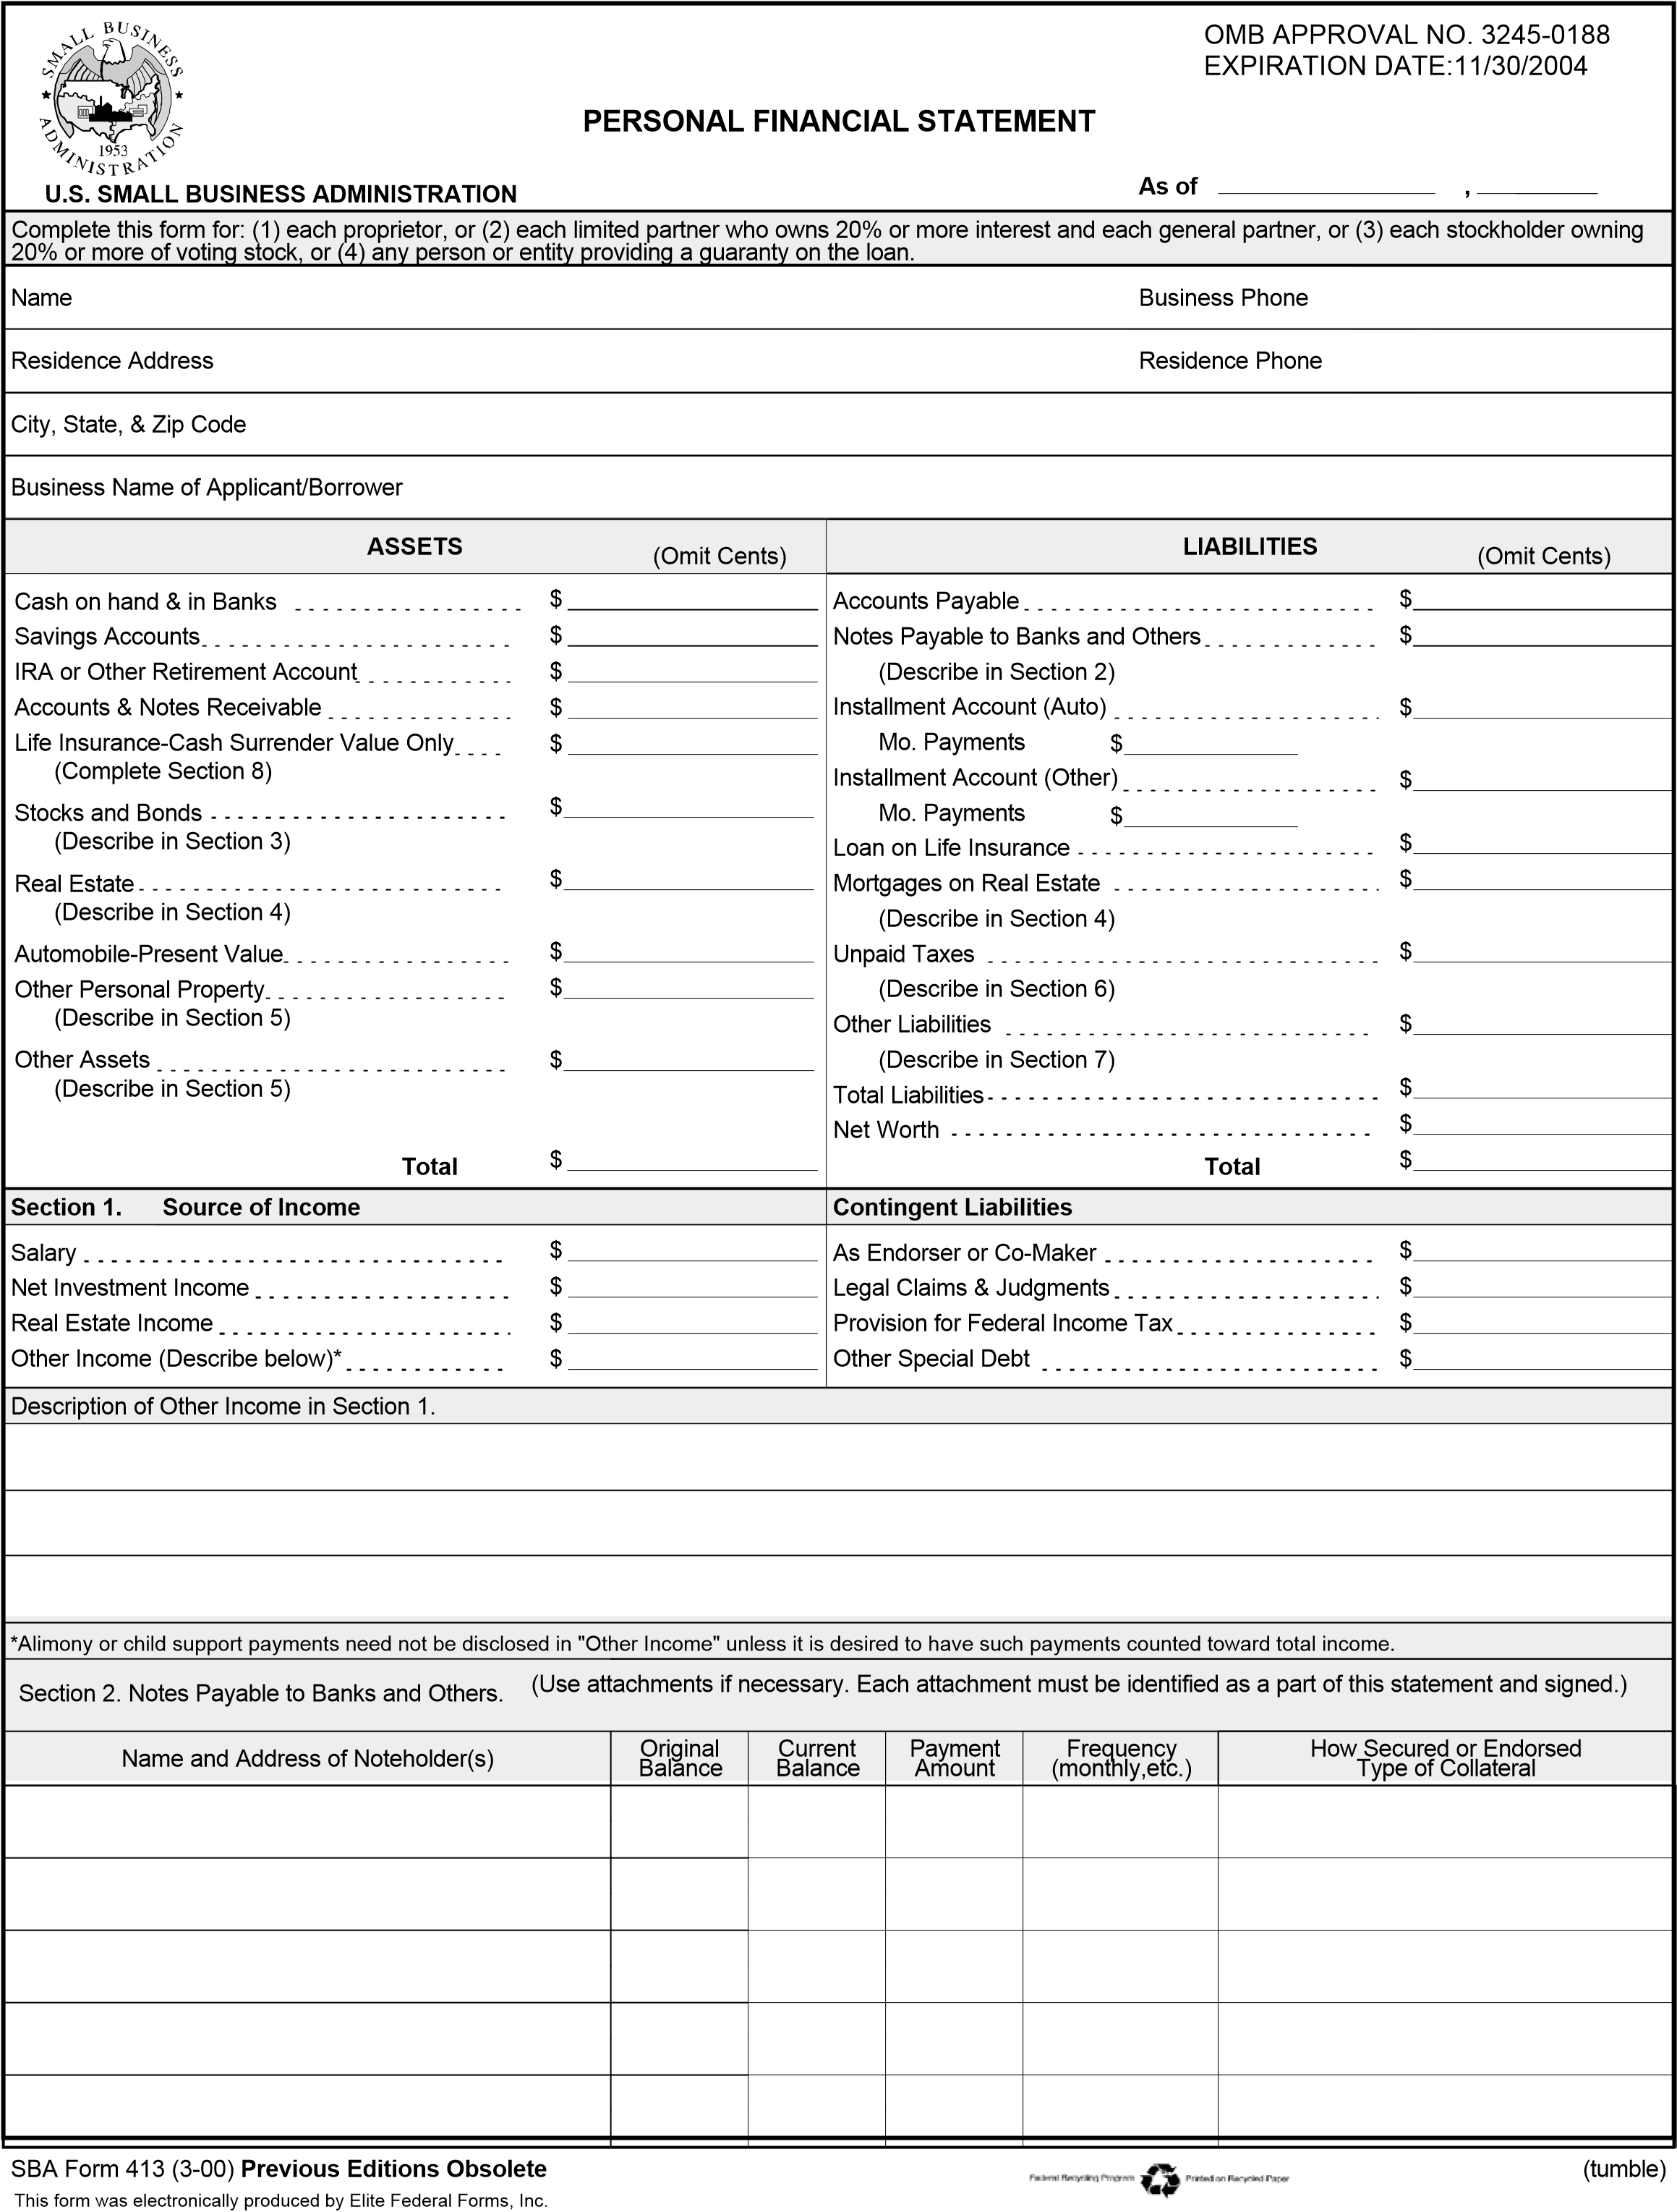
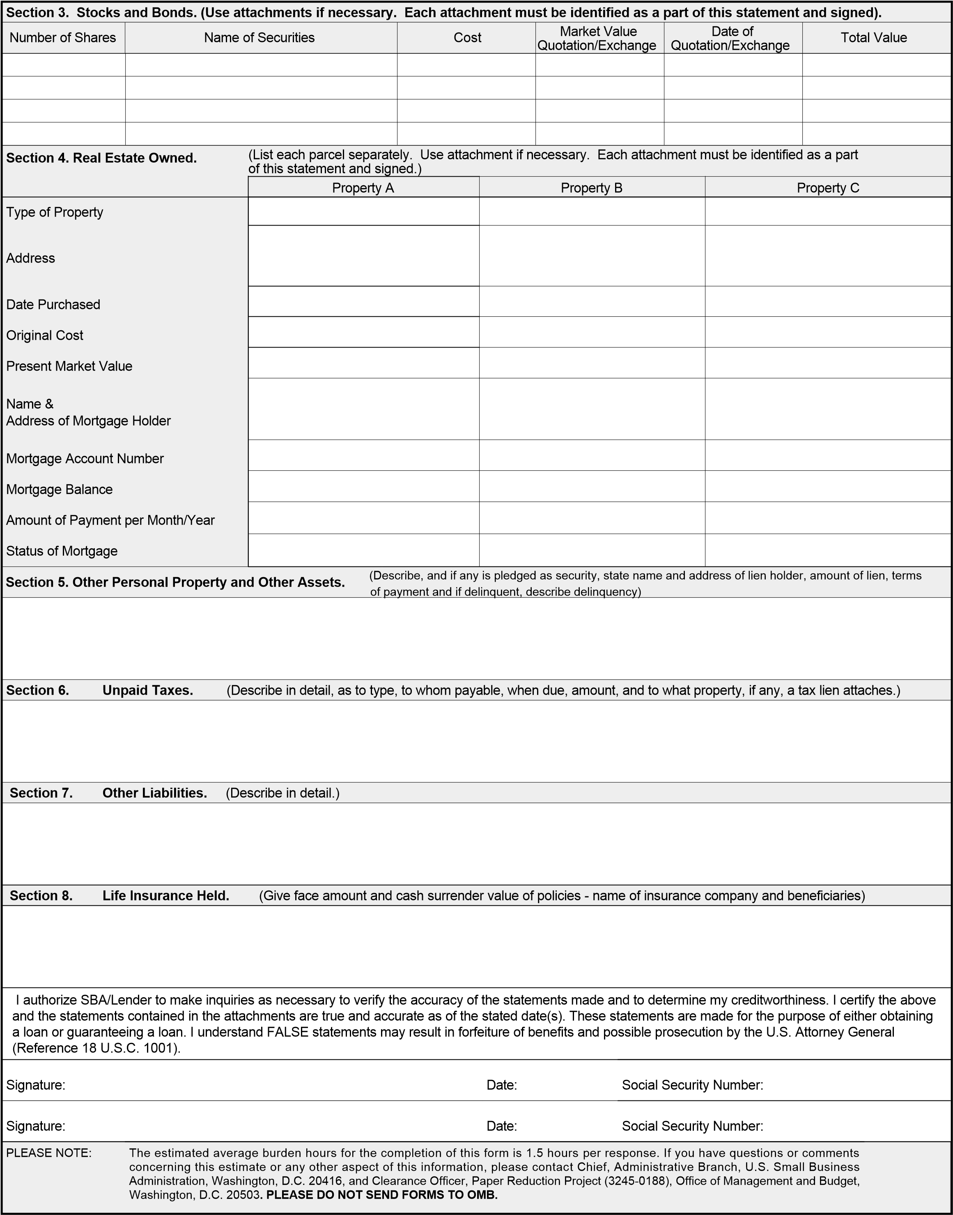

PERSONAL RESUME FORM
TO BE COMPLETED BY EACH PRINCIPAL INVOLVED IN THE LOAN
If you already have a prepared resume, submit in lieu of this form
Name
 | FIRST |  | MIDDLE | MAIDEN | LAST
Date of birth |  |  | Place of birth |  | Social Security No
U.S. Citizen – If not, please provide alien registration number

City

State

Zip

Home phone

Business phone

City

State

Zip

Home address
From To

% of business owned

Name of company

Full address

City

State

Zip

From

To

Title

Duties

% of business owned

Name of company

Full address

City

State

Zip

From

To

Title

Duties

Immediate past address
From To
Are you employed by the U.S. Government?

If so, give the name of the agency and position

Military Service Background

Branch From To
Rank at discharge Honorable?

Job Description

Work Experience
List chronologically, beginning with present employment

% of business owned

Name of company

Full address

City

State

Zip

From

To

Title

Duties

Education (College or Technical Training)
Name and Location Dates Attended Major Degree or Certificate
1.
Comments:
2.
Comments:
3.
Comments:
4.
Comments:

RENT ROLL
Unit # | Unit Type |  | Tenant Name | Square Feet | Monthly Rent | T | erm |  | Comments
 |  |  |  |  |  | Start |  | End | (Renewals, Rent Increases, etc.)
 |  | Totals:
Rent Roll Certification:
I/We certify that the attached rent roll(s) dated _______________ for the property located at ________________________________________________
Is/are true and correct.
By: ________________________________________________________

